**Cut Bank Area Chamber of Commerce**

P.O. Box 1243 Cut Bank, MT 59427 (406)873-4041

[www.cutbankchamber.com](http://www.cutbankchamber.com) cutbankchamber@gmail.com

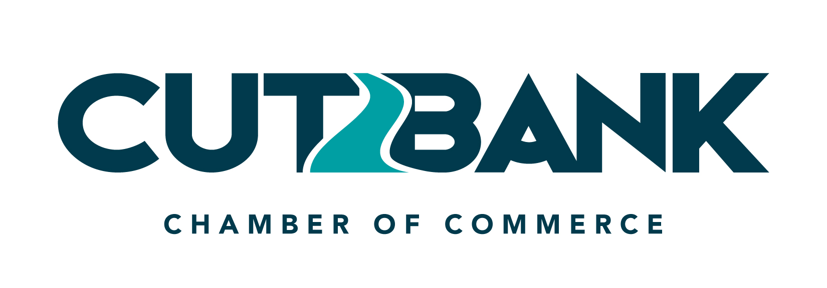

**Minutes**

5:45 pm on Tuesday, April 16th, 2024 – Chamber Board Office

**Directors Present:**

* Larry Schwindt, Rachel Dosch, Jim Woodring, Jenika Sammons, Keith Sammons, Shauna Lunie,

Kim Winchell, Heather Nunn, and Melissa Giard via Teams

**Guest:**

* Mark Boothe – Northern Transit Interlocal

**Regular Business:**

* Approval of March 5th, 2024, Meeting Minutes
* Motioned: Larry Schwindt Seconded: Kim Winchell
* Approval of March 5th, 2024, Financial Report
* Motioned: Jim Woodring Seconded: Larry Schwindt

**Old Business:**

* Business Improvement Awards
* Farmhouse Rags was presented in March. April will be presented to Crazy Heifer. This will be delivered before the next board meeting.
* Board of Directors
  + New Member Nominations presented for Dianne Gobert and Abby Embody
* Reimagining Rural
* Great turnout and brand launching event was held. The updated website is in process. There will be a meeting in May, but the date has not been determined. The committee was awarded a $30,000.00 grant for assistance with updated signage in the community.
* The infrastructure pilot grant has been changed and will now be an award of $3m over 5 years for Glacier County instead of the City of Cut Bank. Lisa Cline has requested a support letter, which Larry Schwindt has agreed to complete it.
* 2024 Membership
* There is currently $13k in the “Membership” Account. The Chamber currently has 89 members and is still receiving membership forms for both businesses and individuals. Larry has updated The Chamber website and will manage it moving forward.
* Chamber Up After Five
* Tee2Green has agreed to host in October.
* It was discussed to approach Cut Bank Brewery to host in May in conjunction with the Community Clean Up event being hosted by The Chamber. Thoughts for this event include A happy hour event and BBQ in the parking lot following the clean-up.
* Kim Winchell suggested also bringing to light in the community the financial struggles that the airport is currently facing.
* Possible other future businesses to host Chamber Up After 5 included Marketplace on Main and Leavitt
* Chamber Banquet
* The Banquet was a great success! We received lots of positive comments from the community regarding the changes that were made. Currently, we have an estimated $6500,00 in profit from the event. The event was featured in the local paper. The most heard feedback from the community was the lack of live music at the event. Questions to consider are if the lack of live music was worth the increased profits. It was discussed that we will begin advertising for the “Best Of” nominations earlier next year and include social media, the paper, and the radio.
* Roundtable Events
* The first Roundtable Event was held on 3/19/24. We will host this event bi-monthly during the noon hour. Please try to attend if possible. The next event is scheduled for 5/14/24. Rachel will add a Zoom option for attending and an email will go out to all members.

**New Business:**

* Community Cleanup Day
* Please see Chamber Up After 5 for more information on this event. The event will be held on 5/21/24 from 5:00 pm to 7:00 pm at Cut Bank Brewery. This is in conjunction with the Chamber Up event for May.
* Make a Difference Day
* It was discussed if a $2000.00 grant to all businesses in town or if we should offer a larger grant to current members and a smaller opportunity for non-member businesses in town. We will discuss this again at the May meeting with the hope of opening the application by the end of May and awarding it at the end of July.
* Northern Transit, Grant Match-Mark Boothe
* This is a dedicated in-town service for our local community that provides transportation services and options from Browning to Great Falls. They are currently trying to obtain a grant that requires matching funds of $6400.00 per year. This grant would allow them to have 2 dedicated Shelby days and 1 dedicated Cut Bank day. They have been approved to utilize their “Ad on a Bus” program. The cost for advertisement on the bus is $400 per year, per bus, and the cost of having the decal built by Big Sky Creative Works. There are currently 9 buses in service. Last year the company provided 20,000 rides to community members. These rides mostly assist with medical care and shopping transportation. This is an opportunity to give back to the community. A motion to advertise for the Chamber was made by Larry Schwindt and seconded by Jim Woodring. Larry or Rachel will reach out to Mark for further information and the steps needed.

**Reminders:**

* May 7th @ 5:45 Monthly Meeting
* May 14th @ 12:00 Roundtable

**Visitors:**

* Comments and/or concerns from visitors
* No comments or concerns brought forward by visitors

**Adjourn:**

**Next Meeting: May 7th @ 5:45 pm**

**Discover Cut Bank ∙ Where the Rockies meet the Plains**